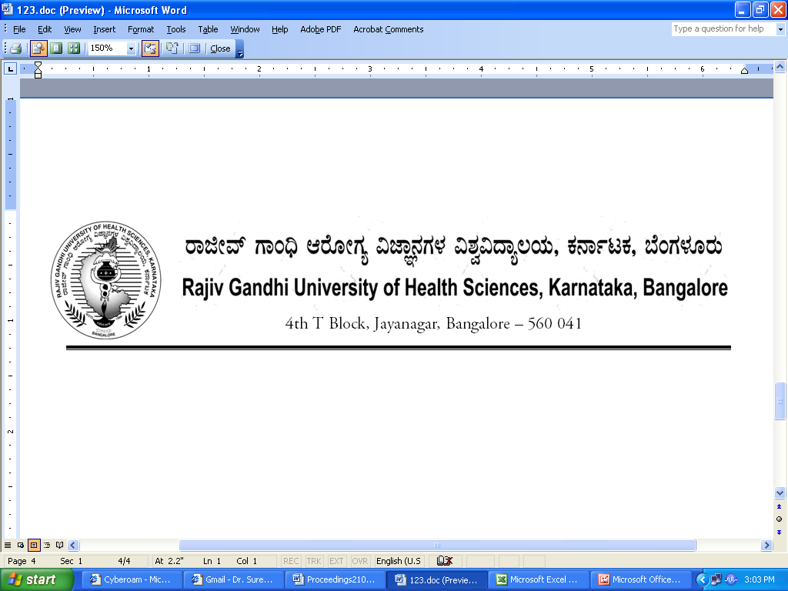

Dr.M.K. Ramesh Ph: 080-26961903, 26961946, Fax: 26961931
Registrar (Evaluation) Email: registrar_evaluation@yahoo.co.in

Reg(E)/Pre-Exam/UG/Oct-Dec/2017-2018/56 Date: 09/10/2017

ADVANCE INFORMATION OF EXAM SCHEDULE

Sub: Conduct of University Under-Graduate Medical and Dental Theory Examinations during December 2017-2018.
**********

The provisional dates for the following Under Graduate University Theory Examinations will commence as notified below.

Faculties | Provisional Date
Medical and Dental | 14th December 2017

The Principals of the concerned colleges affiliated to the University are requested to notify the same on the Notice Board of their colleges for information to the students concerned and circulate the same to all the Staff / Department of your college for information and follow up.

Sd/-
Dr. M.K. Ramesh
Registrar (Evaluation)

To:
All the Principals of Medical and Dental Colleges affiliated to RGUHS for information and needful action.

Copy to:

- PA to Vice-Chancellor/PA to Registrar/PA to Registrar (Evaluation)/Finance Officer,
RGUHS, Bangalore.
- Deputy Registrar (Admn) / Dy. Registrar Computer Section (Eval) RGUHS, Bangalore.
- Asst. Registrar, Regional Center, Belgaum / Gulbarga.
- Guard File.

